1. After the user downloads and installs the app, a Welcome Page should appear first.
On the Welcome Page, the following options should be available:
- A Phone Number field where the user can enter their mobile number.
- A “Get OTP” button to send an OTP to the entered phone number.
This means the user first enters their phone number and then clicks on the “Get OTP” button.
After the user enters their mobile number and clicks on “Get OTP”, an OTP (One Time Password) will be sent to the entered mobile number.
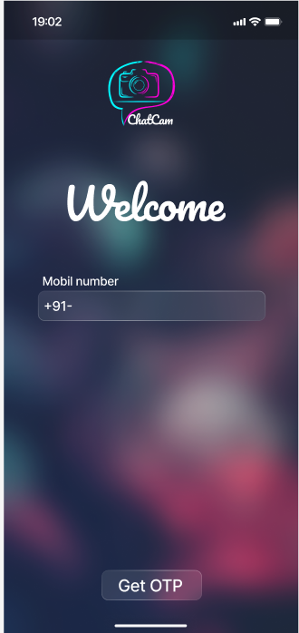

2. On this screen, the user will have an input field to enter the OTP received on their mobile and a “Submit” button. After the user enters the OTP and clicks on Submit, the system will verify the OTP. The OTP should expire after 5 minutes. After that, the Resend button should appear. When the user clicks on Resend, a new OTP should be sent again to the mobile number. If the OTP is correct, the account verification will be completed and the user will be taken to the next screen. If the OTP is incorrect, an error message should be shown and the Resend option should be displayed. After resending, the OTP should be verified again.
If the OTP is not received, there should be a Back button at the top of the page so that the user can go back and check the mobile number they entered.
The mobile number entered initially by the user should be automatically populated wherever the “Mobile Number” field appears in the app. There should be no edit option for the mobile number. One mobile number can be used only once.
If the user wants to use a different mobile number, they must uninstall the app and install it again to log in with a new number.
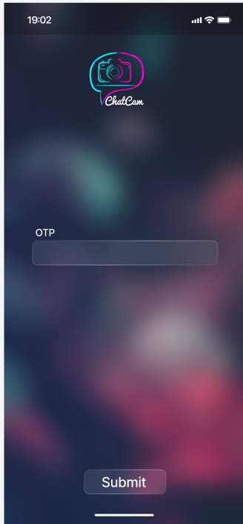
For example, like WhatsApp: a WhatsApp user can log in with only one mobile number. If they want to use a different number, they uninstall WhatsApp, reinstall it, and then log in with the new number.

3. On this screen, before creating the account, the user must read and accept the Terms & Conditions. After completing login or OTP verification, the app will display this screen. It will show the app’s terms, conditions, and policies in text format. The user can scroll and read them.
At the bottom of the screen, there will be two buttons — Decline and Accept. If the user clicks on Accept, it will be considered that they have agreed to the terms, and the app will take them to the next screen. If the user clicks on Decline, the account process will be stopped, or the user may be exited from the app.
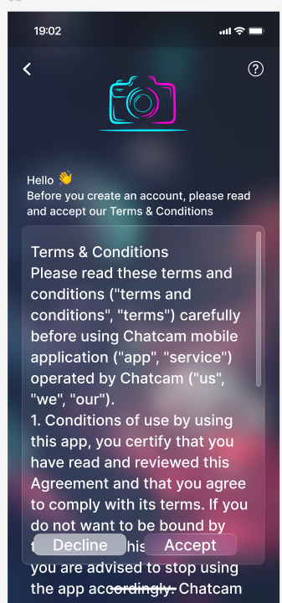
If the user wants to go back, there should be a Back button on the top left side of the page. Also, the Terms and Conditions should appear when the user clicks on the question mark (?) icon on the top right side.
4. After accepting the Terms & Conditions, the app will take the user to the User Details filling screen. Here, there will be fields to enter Full Name, Mobile Number, State, District Name, City Name, Mandal Name, and Village Name. After the user fills in all the required details and clicks on the Submit button, the information will be saved on the server.
The mobile number field should automatically display the number that was entered initially, and it should be disabled.
After the user enters the State name, the District field should automatically display the list of districts belonging to that state from the database. After selecting the District name, the City field should automatically show the list of cities under that district. After selecting the City, the Mandal field should display the mandals related to that city. When the user clicks on the Village field, it should show the list of villages under the selected mandal.
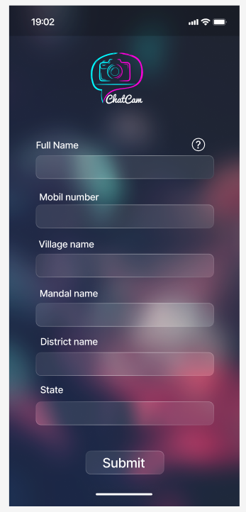
5. On this screen, there will be fields for the user to enter their Profile Name, Mobile Number, City, and Category. There should also be an option to upload a profile photo. After the user enters all the details and clicks on “Continue,” the information will be saved.
The mobile number field should automatically display the number entered initially, and it should be disabled.
Users can upload posts only related to the Category selected in their profile. This is because the app content is completely filtered based on City and Category. Whatever Category the user selects, their posts and chats should be visible only to users belonging to the same Category. Users from other Categories should not be able to see them.
If a user wants to post content related to a different Category, they must first go to their Profile and change the Category. Only after changing the Category should they upload content related to that Category.

Profile name should allow only10char , the city should be auto populated search based on state from farm page , example user seletes AP then 175 constienties should shown , by deafault user can able have the option forauto populated search at any field .

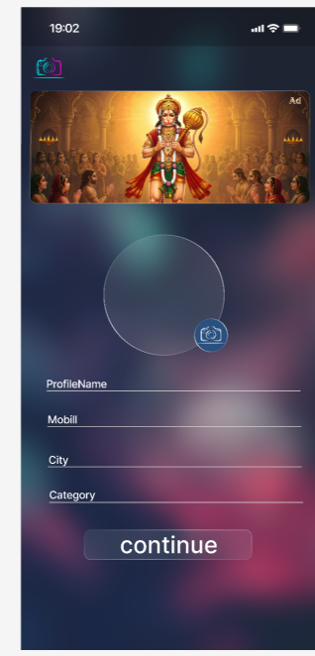

6. This screen is the Home Screen of the app. At the top, there should be a banner image where advertisements will be displayed. The image provided by the admin should automatically adjust and fit properly.
Below the banner, there should be two options: City and Category. When the user clicks on City, they should be able to select their desired city. Through the Category option, they can select the available categories in the app.
In the City section, the user can select their city (for example, Guntur). The City name should be taken by default from the City Name field in the Profile page. If the user wants to change it, they should be able to modify the city selection.
In the Category section, options such as “Cameras & Drone,” “Video Editing & Album Design,” “Printing Lab,” and “Human Resources” will be displayed. The user should have the option to select the category that best suits their needs.
The app should always display chats and posts only based on the selected City + Category combination.
For Example:
a) If Guntur + Cameras & Drone is selected, only posts related to the Cameras & Drone category from Guntur city should be displayed.
b) If Guntur + Video Editing is selected, only posts related to Video Editing from Guntur should be displayed.
c) If Hyderabad + Printing Lab is selected, only posts related to Printing Lab from Hyderabad city should be displayed.
d) If Vijayawada + Human Resources is selected, only posts related to the Human Resources category from Vijayawada should be displayed.
If the user wants to view a different Category, they must go back to the Home screen and select a new Category. Similarly, when they move to a different City, they need to select that City and the required Category again.
At the bottom of the screen, there should be a banner image where advertisements will be displayed. The image provided by the admin should automatically adjust and fit properly.
On the Home screen, while selecting a City, the user should not have to scroll too much. The City field should be designed as a search-based field. When the user clicks on City Selection, a search input field should appear. As soon as the user starts typing the City name, related City names matching the typed letters should be displayed in a list (Auto Suggestion / Auto Complete method).
After selecting both City and Category, when the user clicks on the “Continue” button, the app should display the relevant content, services, or professionals based on the selected City and Category.

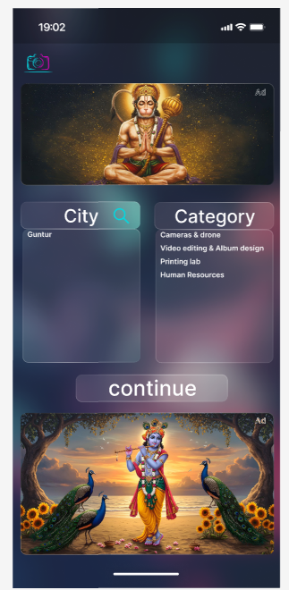

8. After selecting the City and Category, the users or posts related to that selected filter should be displayed here in a list format.
At the top, there should be an input box labeled “Write message.” From there, the user can write a new message or post. Next to it, there should be a “+” button that allows the user to create a new post or upload an image or video. Below this section, an advertisement banner should also be displayed.
Below this section, the user’s details such as Name, Mobile Number, City (for example, Guntur, Andhra Pradesh), and Date should be displayed.
Below these details, the message posted by the user should appear. If the text is long, there should be a “See more” option. When the user clicks on “See more,” the full text of the post should be displayed.
The Chat page should look similar to the Feed page in Facebook. If the text exceeds 3 lines, a “See more” option should be displayed. When the user clicks on it, the full content should be shown. Users should be allowed to upload a maximum of 6 images and 2 videos per post. Each video should have a maximum duration of 2 minutes. The developer should determine the required file size (in MB) for a 2-minute video based on the supported quality and compression settings.
If more than 3 images or videos are added, a “More” option should appear (similar to Facebook), allowing users to view the remaining media content.

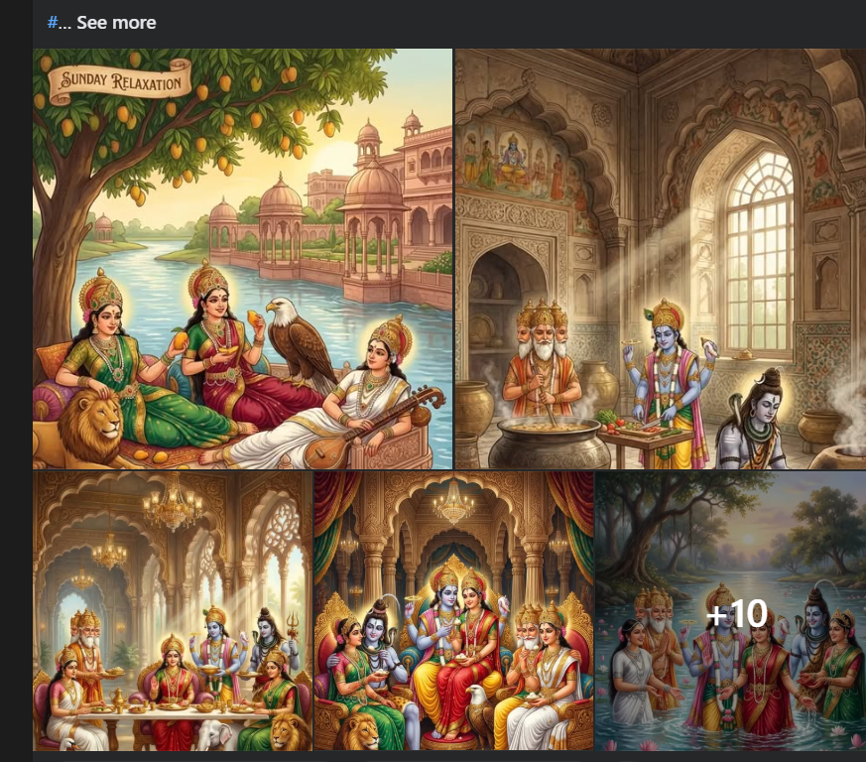

To allow the user to delete their own post, three dots (⋮) should appear next to the user details. When the user clicks on the three dots, a Delete option should be displayed. If the user clicks on Delete, the post created by the user should be deleted.
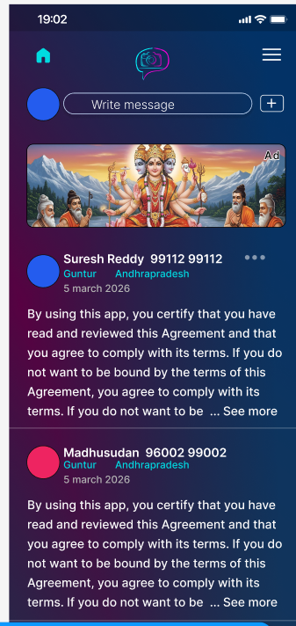

9. After clicking on “Write message” or the “+” button on the Feed screen, or after clicking on the Edit option, the user should be redirected to this page.
At the top, the user’s Name, Mobile Number, and Location (City, Catogogory) details should be displayed. In the middle section, the message typed by the user should appear. If required, there should also be an option to add an image here.

Number , Name would be white with interia Semi bold 18 , City 15 size Interia Medium , light blue from logo camera ,timestamp old as it is Interia Medium size 15.
At the bottom section, there should be three options::
a) Gallery → To select a photo or video from the phone gallery. There should be limits: a maximum of 6 images can be uploaded, and only up to 2 videos can be uploaded. Each video must not exceed 2 minutes in duration.
b) Edit → To modify the message, image, or video that has already been added or typed.
c) Post → After completing all the details, this button is used to publish the post. While publishing the post clean do the clarity and clean mechnishim by using latest open source software or any paid software .
Font all the application should be used Intera , header font would 18 , small header 15 ,
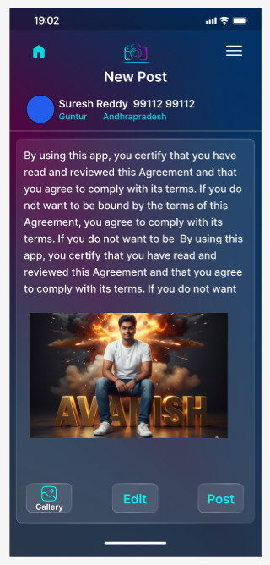
After the user clicks on “Post,” the post should be saved on the server and should be visible to others on the main Feed screen.

10. After clicking Edit on the New Post screen, the user should be taken to the “Add Text” screen.
On this screen, there should be a large text box where the user can type their message or post details. At the top, there should be a “Done” option. After finishing typing, when the user clicks on Done, the text should be saved and the user should be taken back to the New Post screen.
The content written here should become visible to others in the Feed after the user clicks on Post.
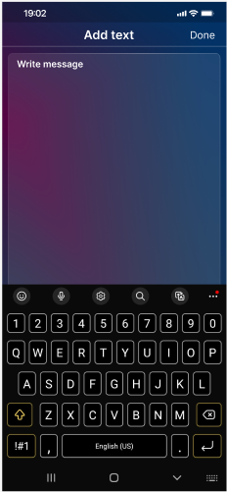

11. “After typing the message on the “Add Text” screen and clicking Done, the user should be redirected back to the New Post preview screen.

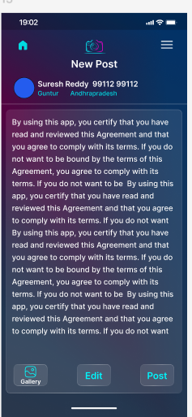

12. On this screen, all the content posted by users should be displayed in a feed format. At the top of each post, the user’s Name, Mobile Number, City, State, and the date of posting should be visible. Below that, the full text message written by the user should be displayed.
After the text, the images uploaded by the user should be displayed in sequence. A maximum of 6 photos can be added in a single post, and they should be viewable by scrolling. If the post includes a video, a play icon should be visible on the video thumbnail. When the user clicks on it, the video should start playing.
After one post ends, the next user’s post should appear immediately below it. In this way, the feed should continue to scroll continuously. If needed, the full text can be read using the “See more” option. By deafault 3 line then show the see more to see total text . Exeample face book . This screen should display all the text, photo, and video posts shared by users in one place within the app.

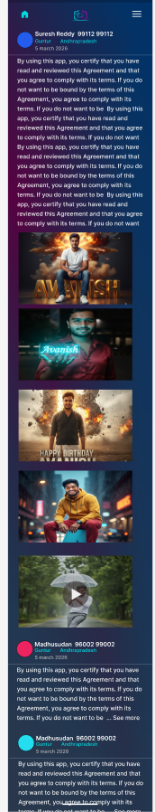

13. This screen functions as the Settings section of the app. At the top, the user’s Name, Mobile Number, City, and State details should be displayed. When the user clicks on “Edit Profile,” they should have the option to modify their profile details.
Through the “Change your location” option, the user can update their current City/Town. Based on the selected City/Town, the feed related to that location should be displayed.
In “About Us,” information about the app will be provided.
In “Privacy Policy,” details about how user data is collected and used will be explained.
Through “Feedback,” the user can send their opinions or suggestions.
In “Regulations & Conditions,” the app’s terms and conditions can be viewed again.
The Change Password and Logout options should be removed from the Settings page.
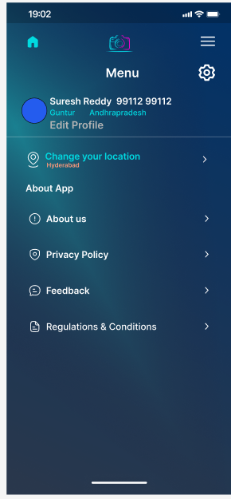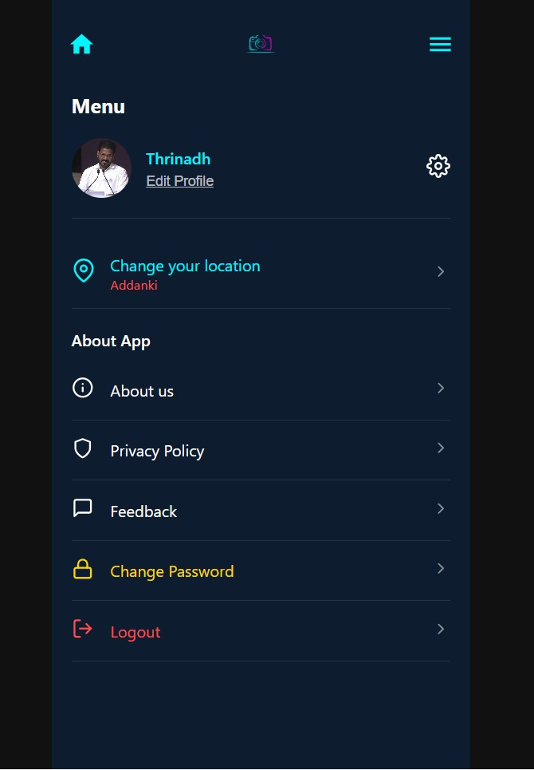
14. After clicking on the “Edit Profile” option in the Settings page, this page should open. Here, the user should have the option to modify their profile details. At the top, a circular profile photo should be displayed. When the user clicks on the camera icon, they should be able to upload a new photo or change the existing one.
At the bottom, there will be fields such as Profile Name, Mobile Number, City, and Category. The user can update these details as needed. After making all the changes, when the user clicks on “Submit,” the updated details should be saved on the server.
The mobile number field should automatically display the initially entered number, and it should be disabled. It cannot be changed.
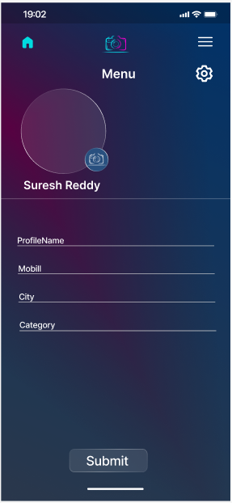

By default profile city/consistency , category should grouped and distpyed in the same group , for feature all modify ordeleted recordedshould have backup mechnishim .

